PROJECT BUDGET AND EMPLOYEE PERFORMANCE ANALYSIS

Hear is a data set in which project and department managements are at risk of being over budget or underperforming ? note that department budget are set at 2-years intervals. We want to know if a year can cover all expenses.

1. **Identify departments and projects in the RED**: understanding which departments or projects are over budget or underperforming.
2. **Data Organization :** Ensure that data from various sources (e.g. ,employee information , salary data, department budgets, and project details) is structured correctly and accessible for reporting.
3. **Power BI Dashboard Development**: Collaborate with us to create a comprehensive dashboard that provides visibility into employee performance , salary distribution , and department project management.

**QUERRY**

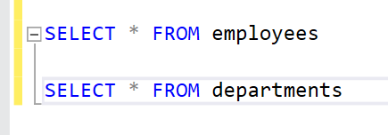

**OUTPUT**

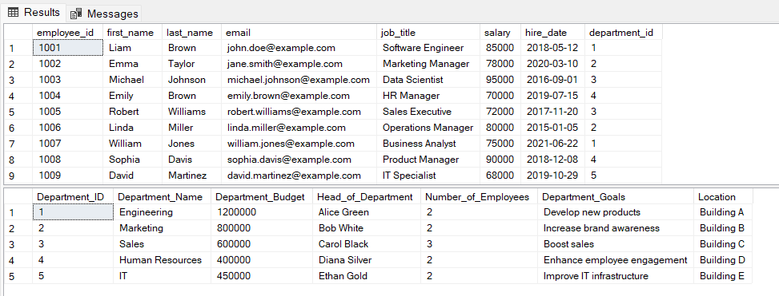

**QUERRY**

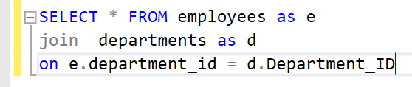

**OUTPUT**

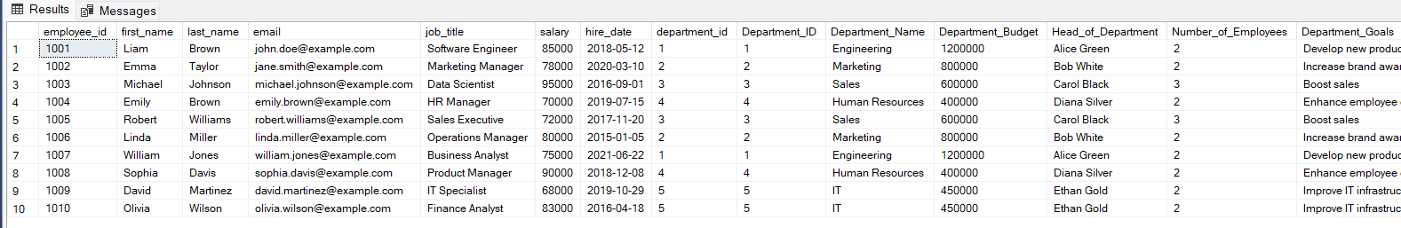

**QUERRY**

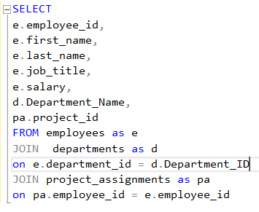

**OUTPUT**

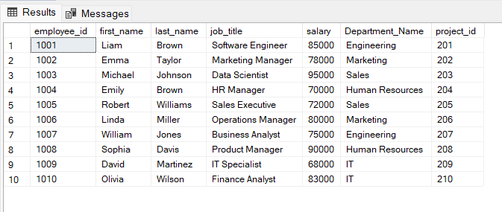

**QUERRY**

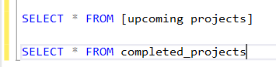

**OUTPUT**

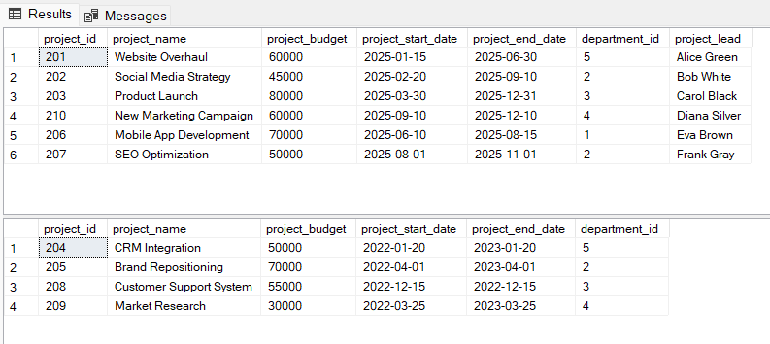

**QUERRY**

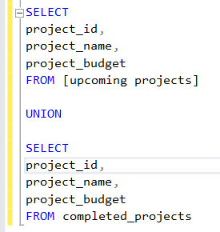

**OUTPUT**

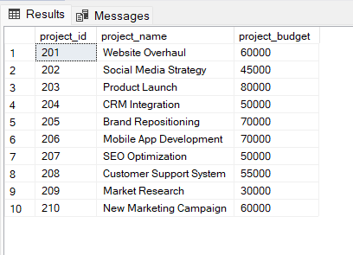

**QUERRY**

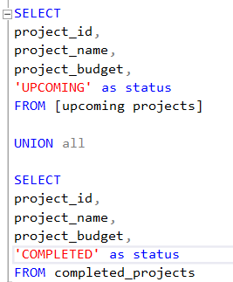

**OUTPUT**

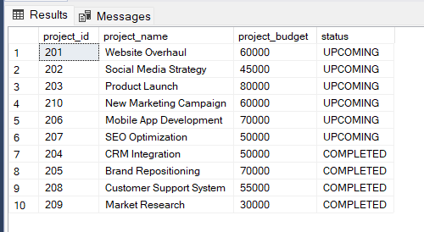

**QUEERY**

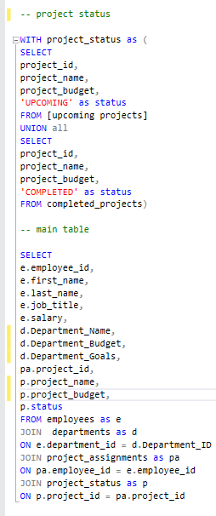

**OUTPUT**

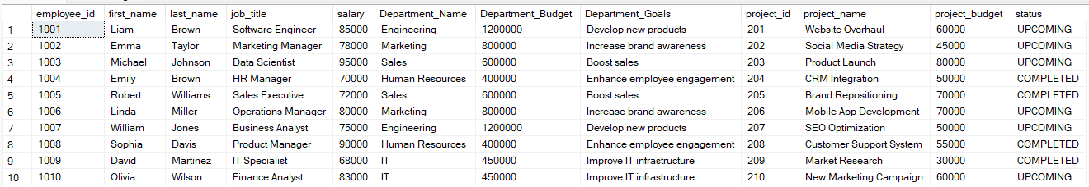

**CONNECTING DATABASE WITH POWERBI DESKTOP**

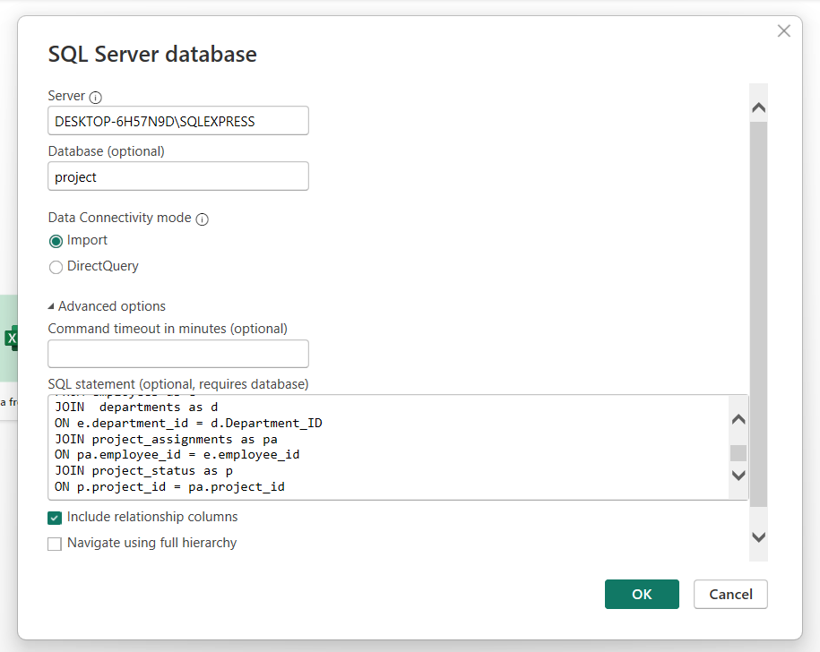

**IMPORTING EMPLOYEES HEADSHOT FROM .CSV FILE**

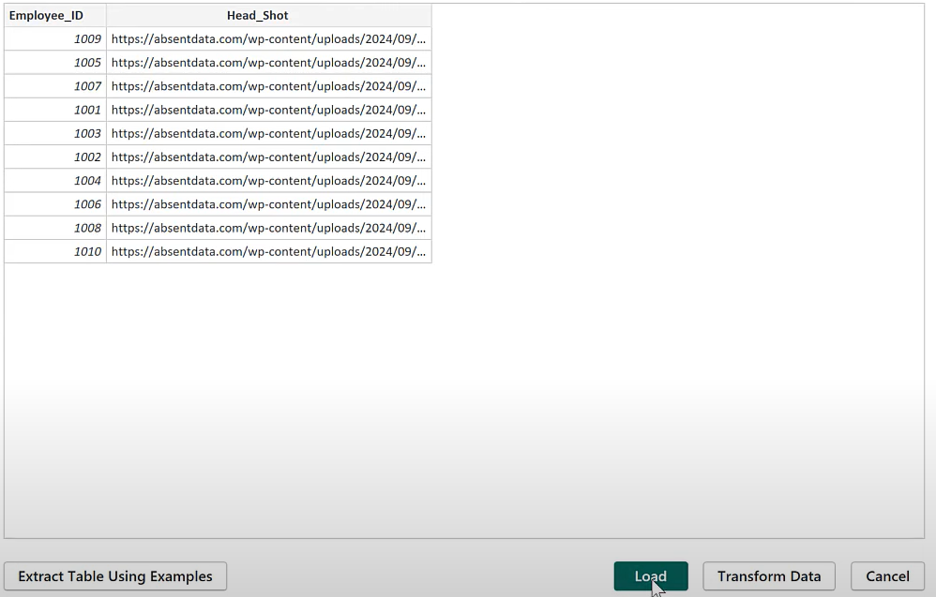

**ADDING A NEW COLUMN (Capital) TO SHOW WHICH DEPARTMENT IS OVER BUDGET**

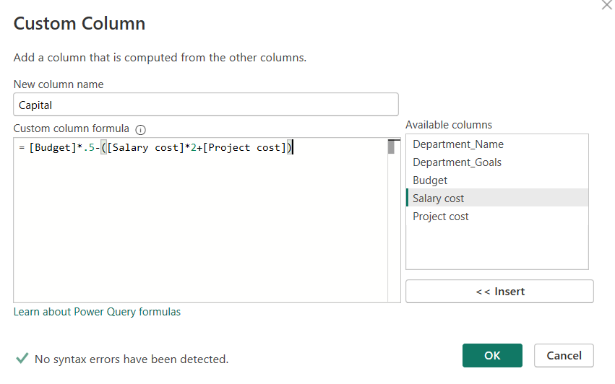

**DASHBOARD**

